**Field Work**

**On**

**Instagram**

**Submitted to**

**KCES’s Institute of Management and Research, Jalgaon**



**Submitted by**

**Name: Mr. Gaurav Vijay Saindane**

**Email id: gauravsaindane007@gmail.com**

**Name: Mr. Nilesh Ramesh Sapkale**

**Email id: nileshsapkale007@gmail.com**

**Under the Guidance of**

**Name**: **Mis. Aarti Hinge**

**In Partial Fulfillment of**

**Bachelor of Computer Application**

**Kavayitri Bahinabai Chaudhari North Maharashtra University, Jalgaon**

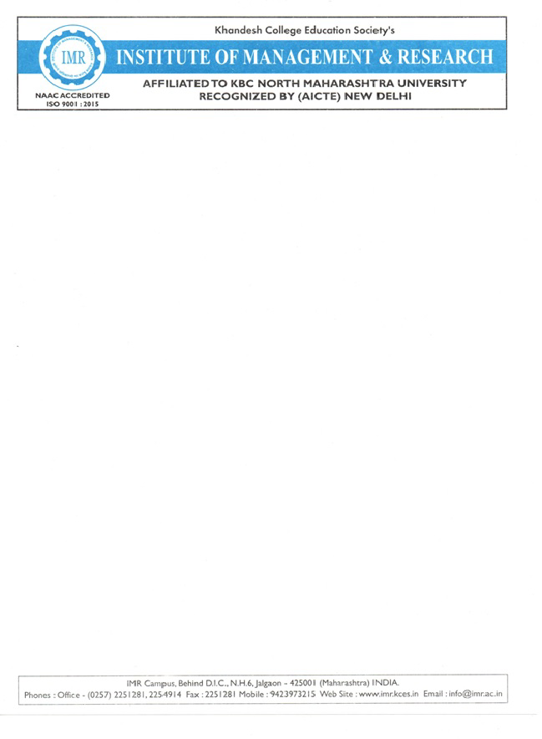

**CERTIFICATE**

This is to certify that **Mr. Gaurav Vijay Saindane & Mr. Nilesh Ramesh Sapkale** student’s of BCA from **KCES’S Institute of Management and Research,Jalgaon** has completed the Filed work entitled **Instagram** both has submitted satisfactory field report in partial fulfillment of the requirement for the degree of BCA during academic year **2025-2026.**

It is the original work and sincerely completed the field work. I am fully satisfied

with his/there performance.

**Mis. Aarti Hinge**  **Mis. Aarti Hinge**

**Internal Guide Coordinator**

DR. Dipali Kirenge

**External Examiner I / Examiner II HOD**



**ACKNOWLEDGEMENT**

We have great pleasure in submitting this Field Work on **“Instagram”** to **Kavayitri Bahinabai Chaudhari  North Maharashtra University, Jalgaon.**

 It is humble brief that any Field Work can be carried out with success by a two person. Many other personalities helpings to accomplished this project and it is our duty to express our appreciation to them.

 We are indebted to **Miss. Aarti Hinge** for helping us as guide and  allow us to do the Field Work at their site.

 We wish to thank the teaching staff, our friends and persons who help us directly or indirectly for completion of Field Work.

**DECLARATION**

We hereby declare that the project work entitled **“ Instagram ”** has carried out result on the basis of investigations and analysis by us under the guidance of : **Mis. Aarti Hinge**

 We further declare that this work has not been submitted in partly or fully to any other University or Institute for the award of any other degree. Material obtained from other source has been daily acknowledged in the Field Work.

**INDEX**

| **Sr.No** | **TOPIC** | **Page no.** |
| --- | --- | --- |
| **1** | **Abstract** | **7** |
| **2** | **Indroduction** | **8** |
| **3** | **Project Field work topic/literature Review** | **9** |
| **4** | **Objectives** | **10** |
| **5** | **Methodology** | **11** |
| **6** | **Result and Discussion** | **13** |
| **7** | **Recommendation and Future Work** | **16** |
| **8** | **suggestion** | **18** |
| **9** | **conclusion** | **19** |
| **10** | **Reference** | **20** |
| **11** | **Questionnaire** | **21** |

1. **Abstract:**

Instagram is a widely used **social media platform** that focuses on **photo and video sharing**. Launched in **2010** by **Kevin Systrom** and **Mike Krieger**, it allows users to **capture, edit, and share** moments of their lives with followers around the world. Over time, Instagram has evolved from a simple photo-sharing app into a **powerful tool for communication, marketing, and creativity**.

It provides various features such as **Stories, Reels, Live videos, and IGTV**, which help users express themselves and engage with others. The platform also plays a significant role in **digital marketing** and **business promotion**, offering tools for brands and creators to reach global audiences.

Overall, Instagram has transformed the way people **connect, communicate, and consume content**, becoming a key part of modern digital culture.

**2.Introduction:**

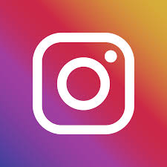

Instagram is a popular **social media platform** that allows users to **share photos, videos, and stories** with their followers. It was launched on **October 6, 2010**, by **Kevin Systrom** and **Mike Krieger**, and later acquired by **Facebook (now Meta Platforms)** in 2012.

Instagram enables users to **capture and edit images**, **apply filters**, and **connect with others** through likes, comments, and direct messages. Over time, it has evolved into a platform for **personal expression, business promotion, influencer marketing**, and **brand building**.

Features like **Reels, IGTV, Stories, and Live streaming** make it an engaging space for creativity and entertainment. Today, Instagram has over **a billion active users** worldwide and plays a significant role in **digital marketing, online communities, and visual communication**.

**3.Project Field Work Topic/ Literature Review :**

**“A Study on the Impact and Usage of Instagram as a Social Media Platform”**

This project focuses on understanding how Instagram influences communication, lifestyle, and business promotion in today’s digital world. The study explores user engagement, social connections, and marketing trends through Instagram’s features such as Stories, Reels, and Live videos. It also examines how individuals and brands use Instagram for creativity, awareness, and income generation.

Instagram has been widely studied as one of the most popular social networking platforms emphasizing **visual communication**.  
According to various studies:

* **Sheldon & Bryant (2016)** found that people use Instagram mainly for **social interaction, self-expression, and documentation**.
* **Hu, Manikonda & Kambhampati (2014)** analyzed Instagram content and concluded that users share photos to build their identity and connect with communities.
* **Djafarova & Rushworth (2017)** highlighted Instagram’s growing role in **influencer marketing** and **consumer behavior**, especially among young users.
* Research also shows that Instagram affects **mental health and self-image**, both positively and negatively, depending on usage patterns.

Overall, the literature suggests that Instagram is not just a photo-sharing app but a **powerful platform for communication, branding, and social influence**.

**4.Objectives:**

**To Connect People Globally**  
Instagram aims to bring people together by allowing them to share their lives, ideas, and experiences through photos and videos.

1. **To Encourage Visual Expression**  
   The platform promotes creativity and self-expression by letting users edit and present visual content in unique ways.
2. **To Build Communities**  
   Instagram helps people form and join communities based on shared interests, hobbies, or goals.
3. **To Support Businesses and Creators**  
   It provides tools for brands, influencers, and entrepreneurs to promote their products, reach audiences, and grow their business.
4. **To Provide Entertainment and Inspiration**  
   Through reels, stories, and explore pages, Instagram offers users fun, educational, and inspiring content.
5. **To Promote Engagement and Communication**  
   Likes, comments, and direct messages encourage interaction and meaningful online relationships.

**5.Methodology:**

The **methodology of Instagram** refers to the way the platform operates and how users interact with its features. It includes the steps, processes, and systems that allow people to share, communicate, and engage visually.

#### 1. User Registration and Profile Setup

Users begin by creating an account using an email, phone number, or Facebook login. They then set up a profile by adding a profile picture, bio, and personal details.

#### 2. Content Creation and Uploading

Instagram allows users to **create and share photos, videos, reels, stories, and live sessions**.  
Before posting, users can edit content using built-in tools like filters, captions, and tags to enhance visual appeal.

#### 3. Engagement and Interaction

Followers can **like, comment, share, and save** posts.  
The **Direct Message (DM)** feature enables private communication, while stories and reels promote quick engagement.

#### 4. Algorithm and Feed Management

Instagram uses a **machine learning algorithm** to display personalized content based on user interests, interactions, and behavior.  
The Explore tab suggests new content according to engagement history.

#### 5. Hashtags and Discoverability

Users add **hashtags (#)** to increase visibility and reach.  
Hashtags help categorize posts and connect people with similar interests.

#### 6. Business and Analytics Tools

For professional accounts, Instagram provides **Insights** — data on impressions, reach, followers, and engagement — to help users improve content performance.

#### 7. Advertising and Monetization

Brands and creators can use **Instagram Ads** and **sponsored posts** to promote products or earn revenue.  
This makes Instagram a key platform for **digital marketing and influencer collaborations**.

**6.Result and Discussion**:

**Results:**

The study or analysis of Instagram shows that it has become one of the **most popular and influential social media platforms** in the world. It has successfully connected millions of users through **visual content sharing**.  
Some key results observed are:

1. **High User Engagement:**  
   Users spend a significant amount of time daily on Instagram, interacting through likes, comments, reels, and stories.
2. **Growth in Digital Marketing:**  
   Businesses and influencers use Instagram as a **marketing and promotional tool**, helping brands reach larger audiences.
3. **Platform for Creativity:**  
   Instagram encourages creativity and self-expression through photos, videos, and aesthetic storytelling.
4. **Community Building:**  
   People form online communities based on common interests, hobbies, and professions.
5. **Global Reach:**  
   Instagram enables users to communicate and share content across countries and cultures.

**Discussion:**

The success of Instagram can be attributed to its **user-friendly design**, **continuous feature updates**, and **strong visual appeal**.  
However, the platform also faces challenges such as **privacy issues, fake accounts, and negative mental health effects** due to social comparison.

Instagram’s role in **digital marketing and influencer culture** has reshaped the way brands interact with customers. The introduction of features like **Reels, Live, and Shopping** has made it not just a social app but a **complete business and entertainment ecosystem**.

In conclusion, Instagram has had a **significant impact on communication, culture, and business**, making it one of the most powerful digital tools in the modern world.

**7.Conclusion/Result:**

successfully connects people through **visual communication**, allowing them to share their lives, ideas, and creativity.

Over the years, it has grown from a simple photo-sharing app into a **powerful platform for entertainment, marketing, and business promotion**. Instagram has helped individuals express themselves, brands reach their audiences, and communities come together around shared interests.

In conclusion, Instagram’s success lies in its ability to **combine creativity, connectivity,** Instagram has become one of the **most influential social media platforms** in the world. It **and technology**, making it an essential part of modern digital life.

**8.Recommendations and Future Work:**

**Recommendations:**

1. **Enhance User Privacy and Security**  
   Instagram should continue strengthening its privacy policies and add more tools to protect users from cyberbullying, hacking, and misuse of data.
2. **Reduce Fake Accounts and Misleading Content**  
   Implement stricter verification systems to detect and remove fake profiles, bots, and false information.
3. **Support Mental Well-being**  
   Introduce features that promote healthy screen time, reduce social comparison, and encourage positive online behavior.
4. **Improve Algorithm Transparency**  
   Make the content recommendation system more transparent so users can better understand how their feeds are curated.
5. **Encourage Educational and Informative Content**  
   Promote quality content related to learning, awareness, and skill development alongside entertainment.
6. **Boost Opportunities for Small Businesses and Creators**  
   Provide equal visibility and fair monetization tools for smaller creators and local businesses.

* **Future Work:**

1. **Integration with Emerging Technologies**  
   Instagram could explore **AI, AR (Augmented Reality), and VR (Virtual Reality)** to create more immersive user experiences.
2. **Advanced Data Analytics for Businesses**  
   Enhance analytics tools to give deeper insights into audience behavior, helping brands strategize better.
3. **Eco-friendly Digital Practices**  
   Encourage sustainable digital behavior and raise awareness about responsible online usage.
4. **Cross-Platform Innovations**  
   Improve integration between Instagram and other Meta platforms (like Facebook and WhatsApp) for seamless content sharing.
5. **AI-based Content Moderation**  
   Use artificial intelligence to detect and remove harmful or inappropriate content faster and more accurately.

**9.Suggestion:**

• **Improve Privacy and Security**  
Instagram should strengthen privacy settings to better protect users from hacking, scams, and misuse of personal data.

• **Reduce Fake Accounts and Bots**  
The platform can introduce stricter verification to limit spam and fake profiles.

• **Enhance Mental Health Features**  
Introduce tools or reminders that encourage users to take breaks and manage screen time.

• **Better Content Moderation**  
Improve detection of harmful or inappropriate content to make Instagram safer for all age groups.

• **Support Small Creators and Businesses**  
Provide more visibility and fair reach to small accounts, not just big influencers.

• **Add More Customization Options**  
Allow users to customize their feeds, control recommendations, and manage what type of content they see.

**10.Conclusion:**

Instagram has become one of the most powerful and influential social media platforms in the world. It has transformed the way people **communicate, express creativity, and share information** through photos and videos. From its beginning as a simple photo-sharing app, Instagram has evolved into a **global platform** for **entertainment, business, education, and digital marketing**.

The platform has played a major role in **connecting people worldwide**, building communities, and providing opportunities for brands, influencers, and creators. Despite challenges such as **privacy concerns and social pressure**, Instagram continues to grow by improving features and promoting positive engagement.

In conclusion, Instagram stands as a symbol of **modern digital culture**, blending technology, creativity, and communication to bring people closer together in a visually inspiring way.

**10.References:**

• Instagram Official Website – <https://www.instagram.com>

• Meta Platforms, Inc. – https://about.meta.com

• Wikipedia – *Instagram* Article: https://en.wikipedia.org/wiki/Instagram

• Statista – *Instagram User Statistics and Reports* – https://www.statista.com

• TechCrunch – *Articles on Instagram Updates and Features* – https://techcrunch.com

• Business Insider – *History and Growth of Instagram* – https://www.businessinsider.com

**11.Questionnaire:**

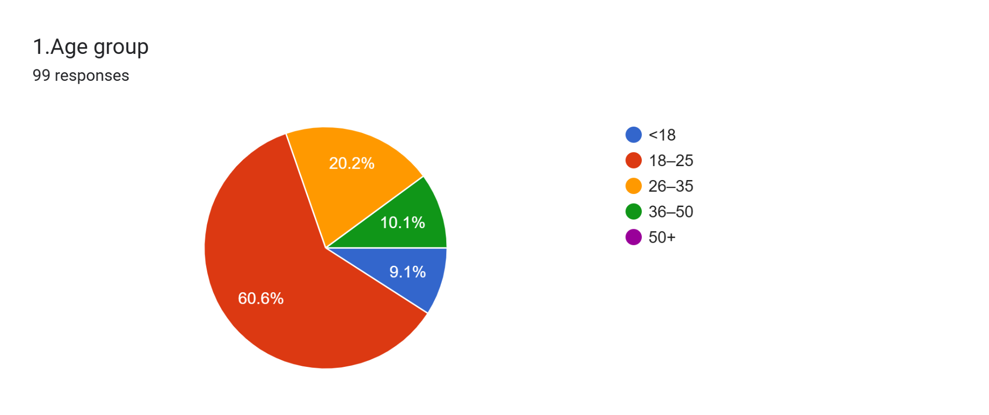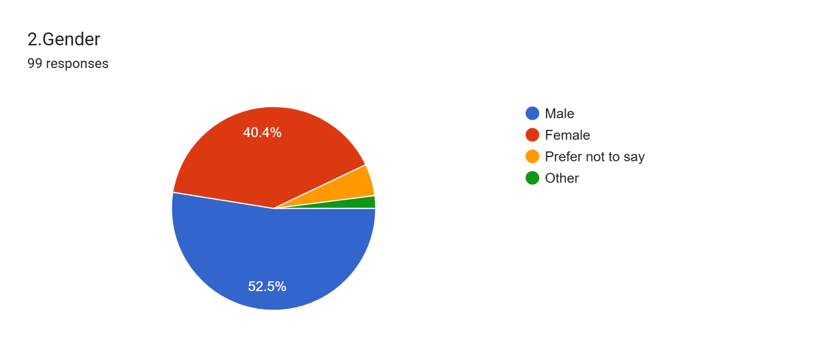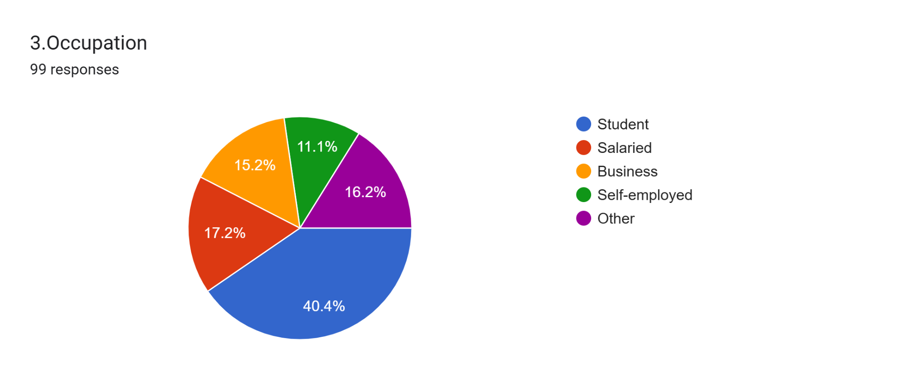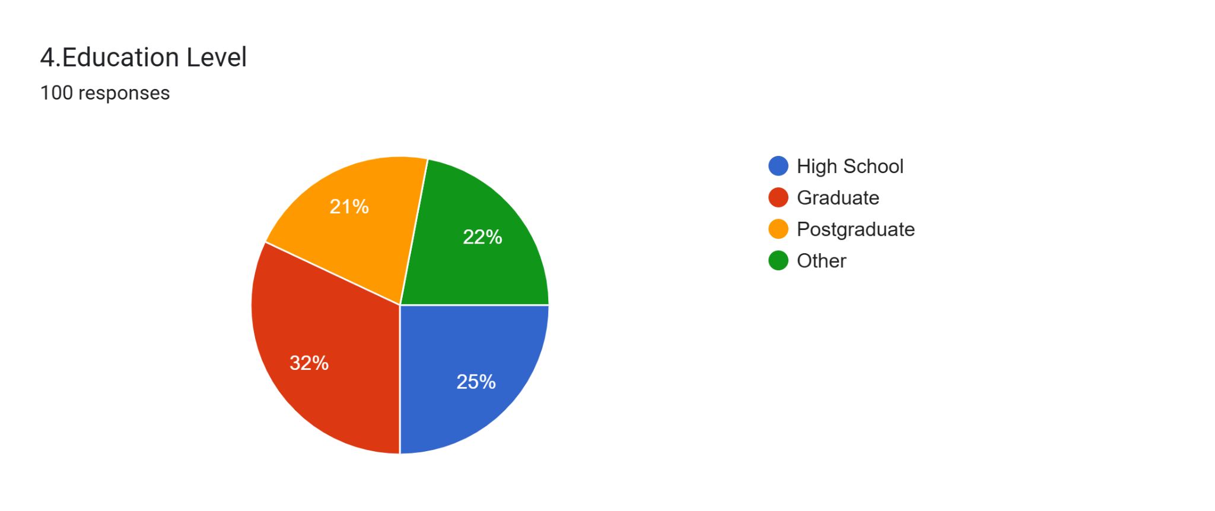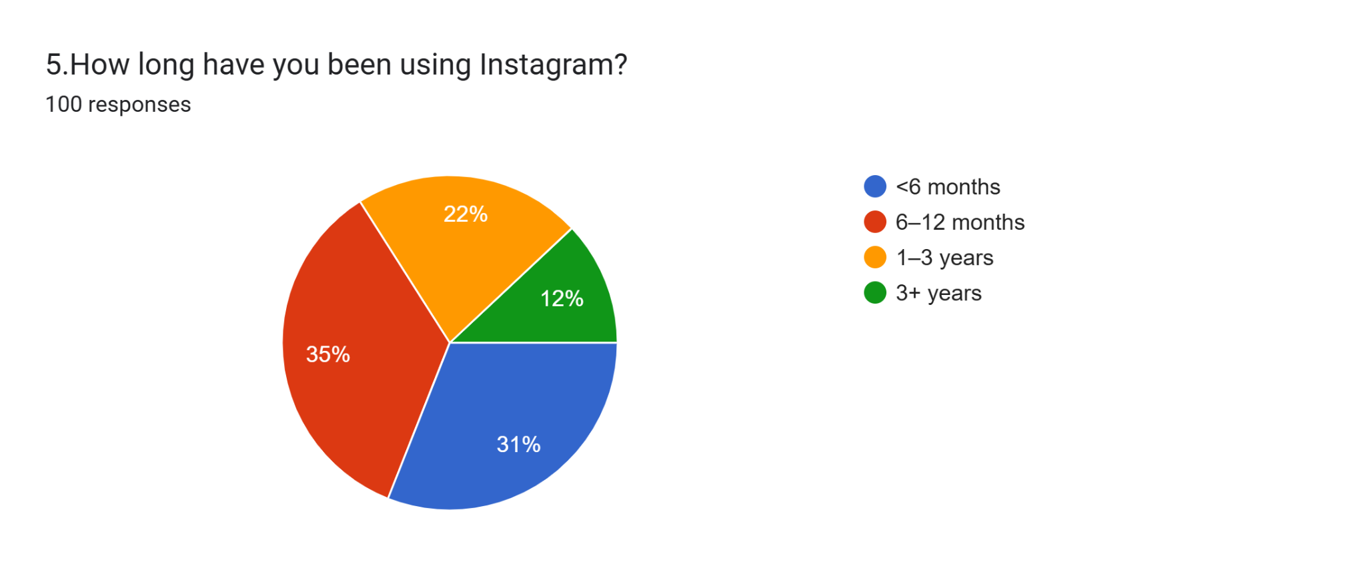Forms response chart. Question title: 6. How often do you use Instagram?
. Number of responses: 100 responses.Forms response chart. Question title: 7. Average time spent on Instagram per day?
. Number of responses: 100 responses.Forms response chart. Question title: 8. Which device do you mainly use Instagram on?
. Number of responses: 100 responses.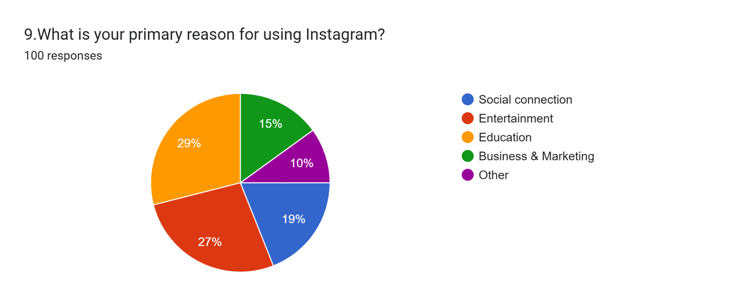Forms response chart. Question title: 10. Which Instagram feature do you use most?
. Number of responses: 100 responses.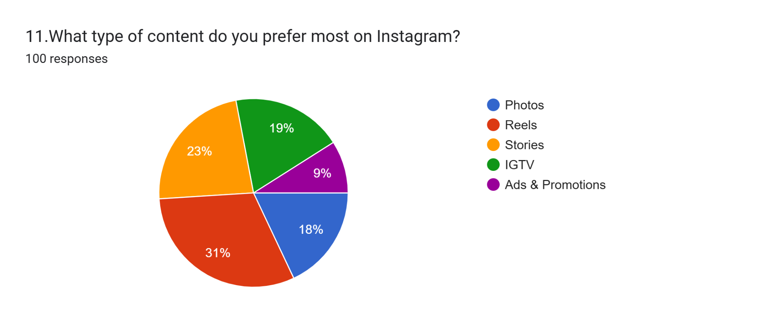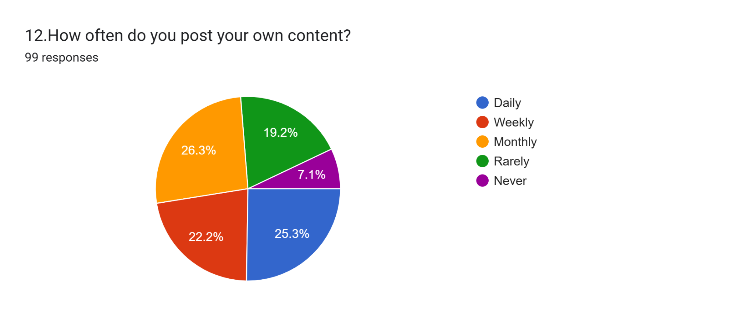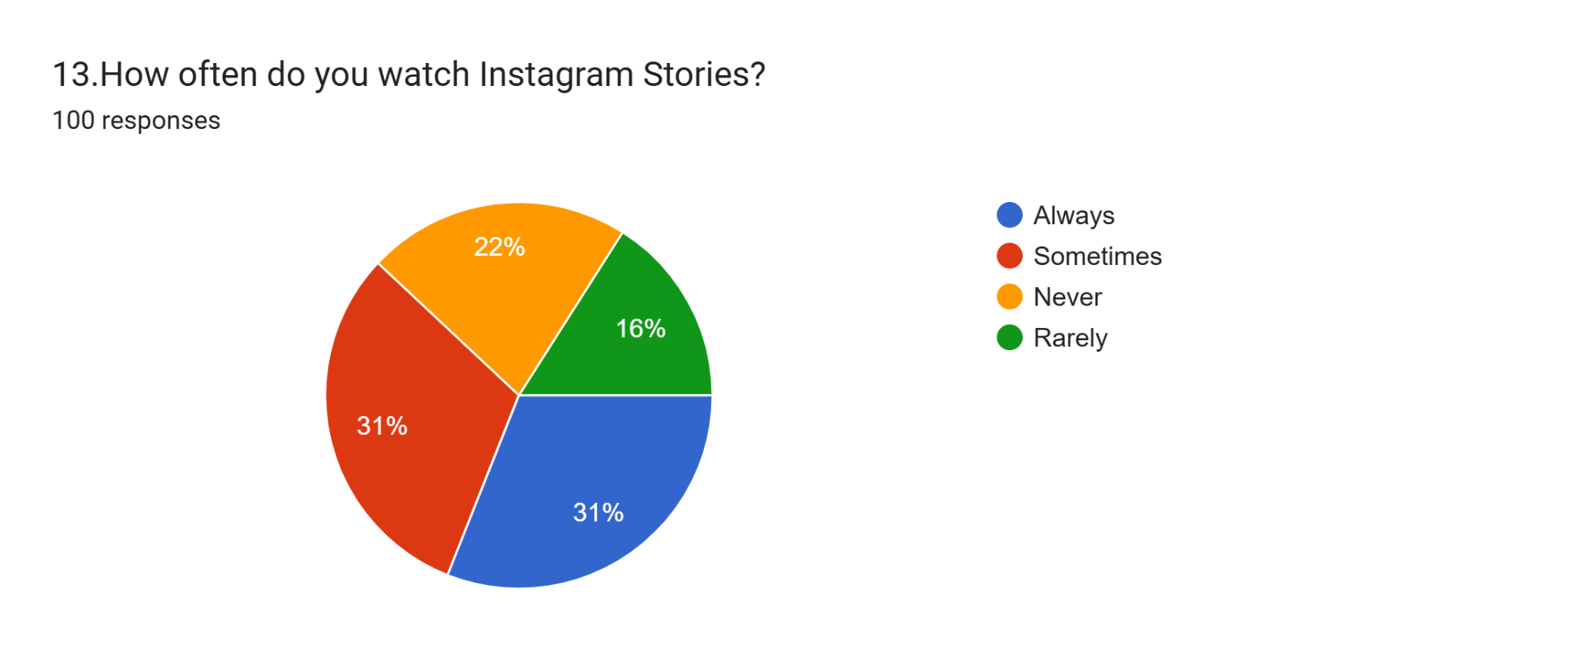Forms response chart. Question title: 14. How often do you watch Instagram Reels?
. Number of responses: 98 responses.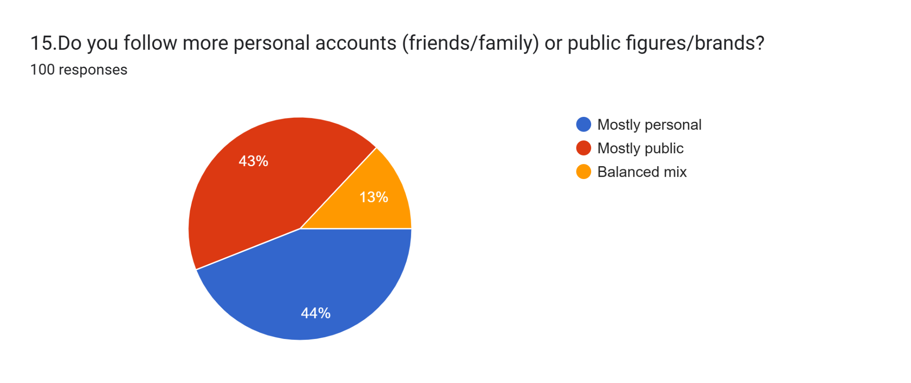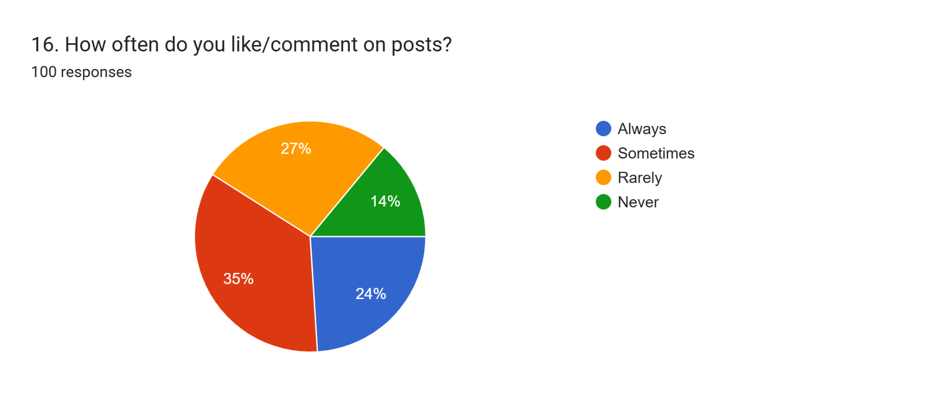Forms response chart. Question title: 17. How often do you share posts or reels with others?

. Number of responses: 100 responses.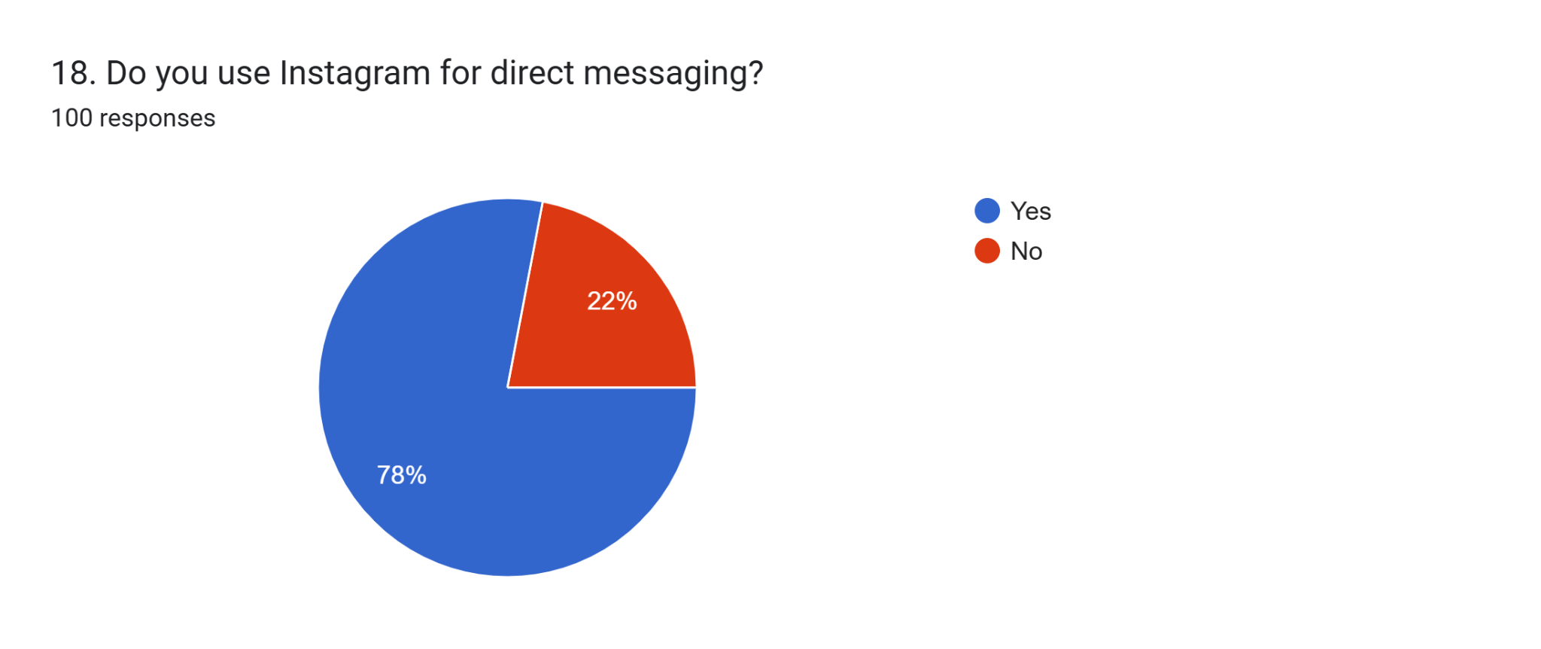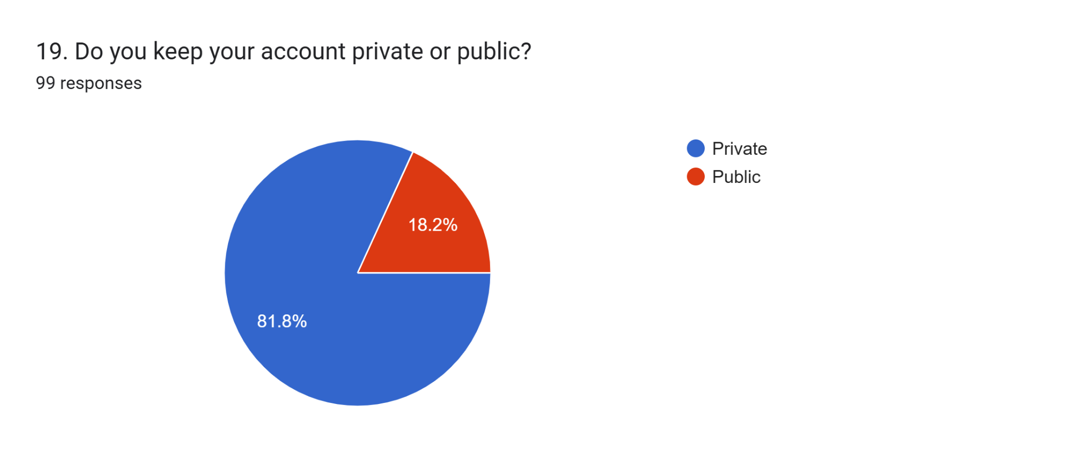Forms response chart. Question title: 20. Have you ever faced harassment, spam, or fake accounts?

. Number of responses: 100 responses.Forms response chart. Question title: 21. Do you use two-factor authentication for Instagram?


. Number of responses: 100 responses.Forms response chart. Question title: 22.Has Instagram increased your social connectivity?

. Number of responses: 99 responses.Forms response chart. Question title: 23. Has Instagram influenced your buying decisions (ads, promotions)?

. Number of responses: 100 responses.Forms response chart. Question title: 24.Do you follow educational/informative accounts on Instagram?

. Number of responses: 100 responses.Forms response chart. Question title: 25. Do you think Instagram creates pressure to present a “perfect life”?

. Number of responses: 100 responses.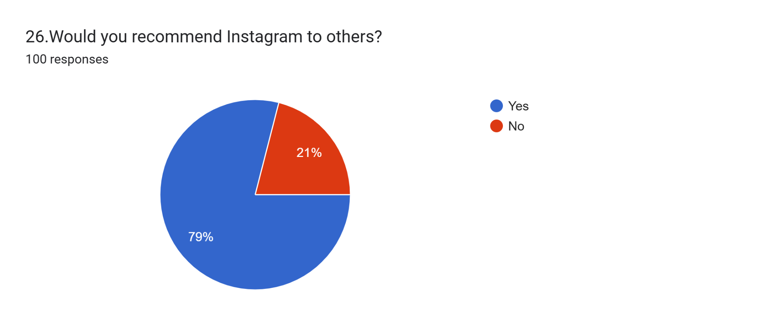Forms response chart. Question title: 27.Do you prefer Instagram over other social media apps (Facebook, Twitter, TikTok, Snapchat)?


. Number of responses: 100 responses.

